[**poojithakavuri02@gmail.com**](mailto:poojithakavuri02@gmail.com)

Assignment – 1 (DATA ANALYTICS WITH TABLEAU)

BAR GRAPH:

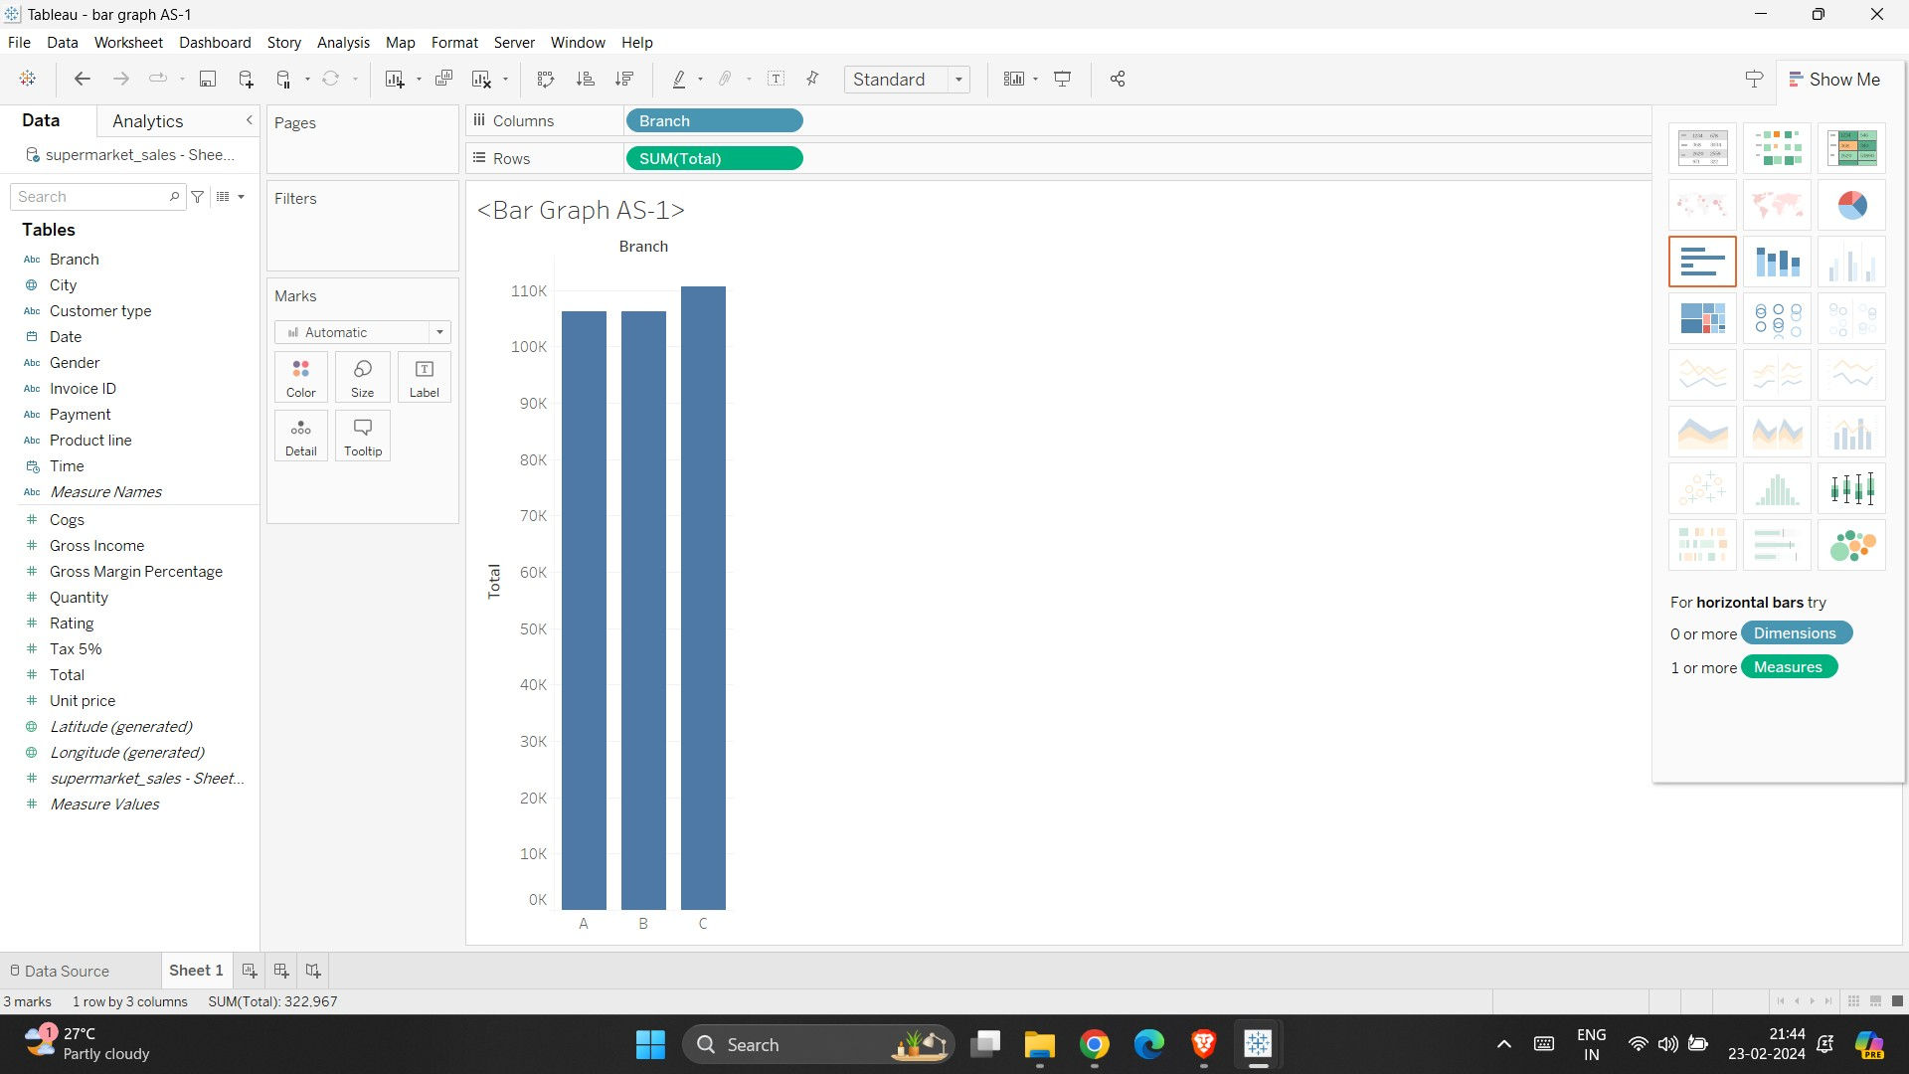

PIE CHART:

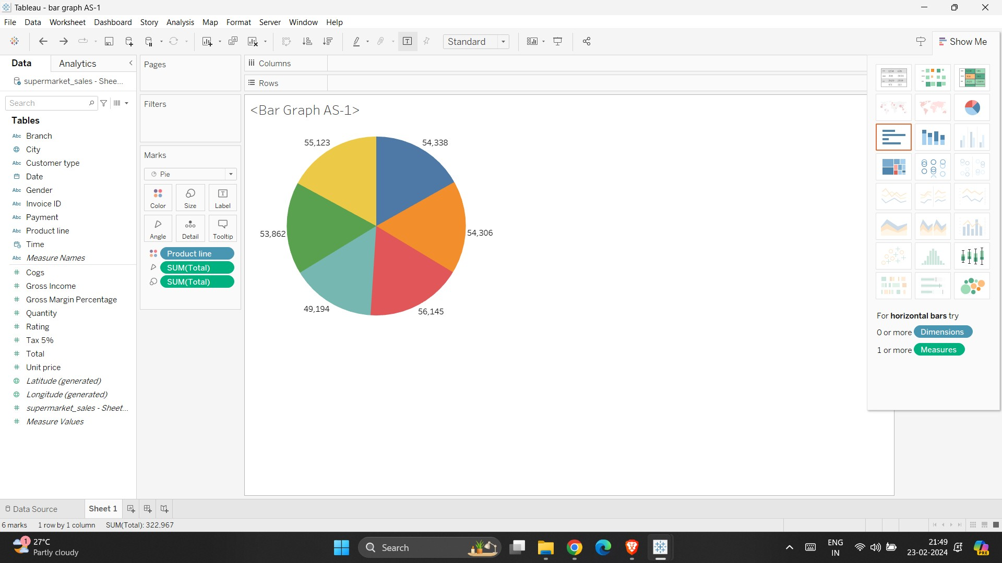

STACKED BAR GRAPH:

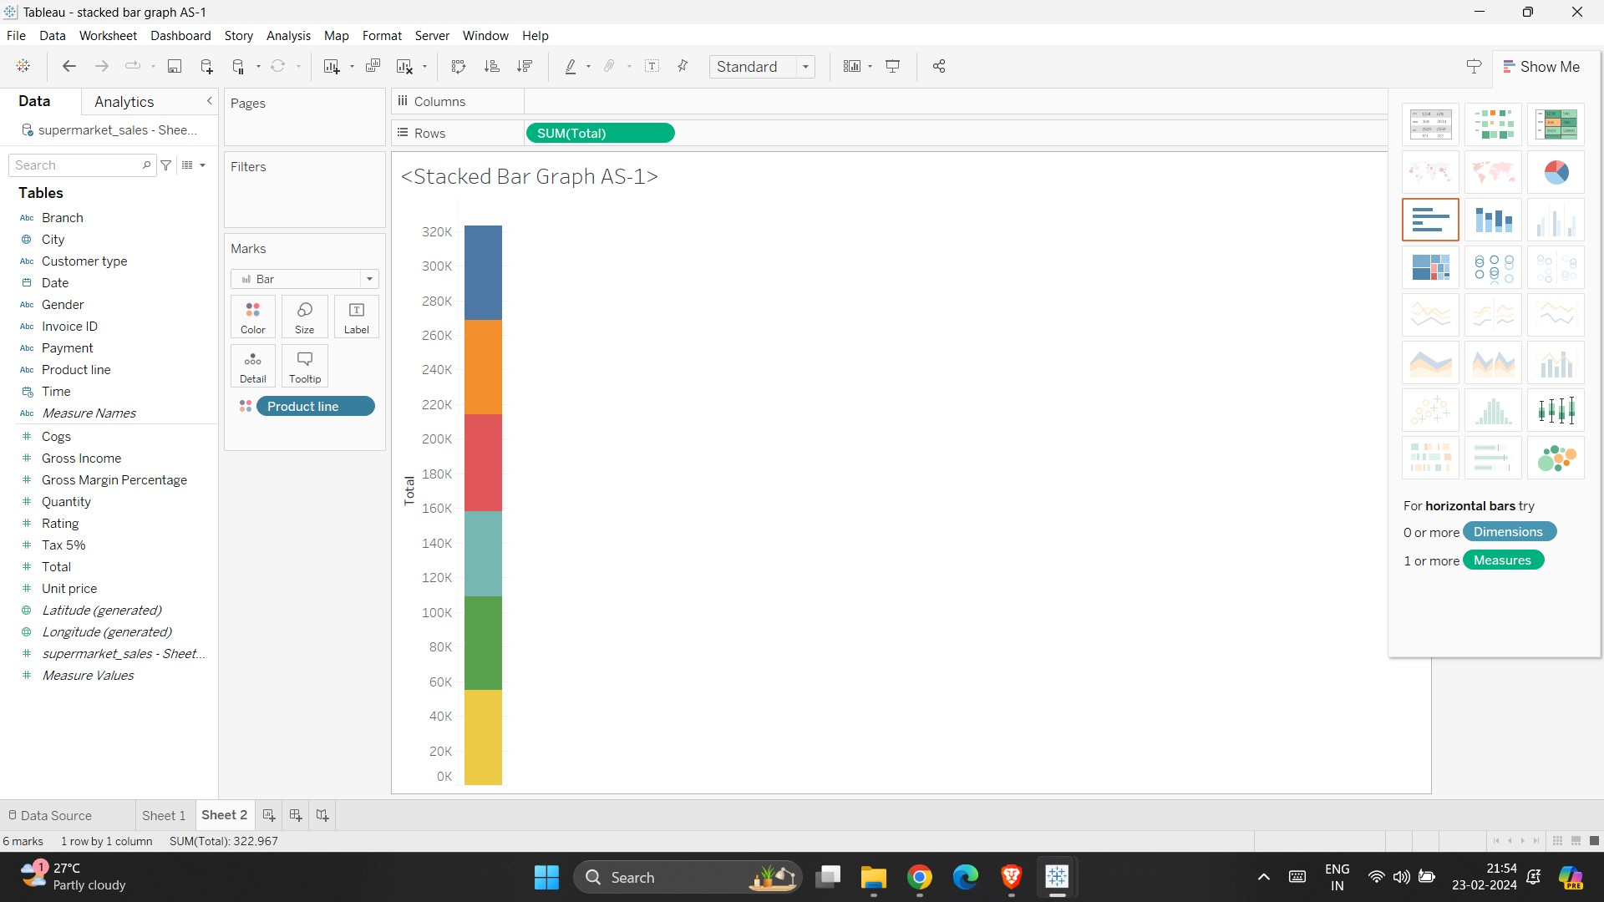

LINE CHART:

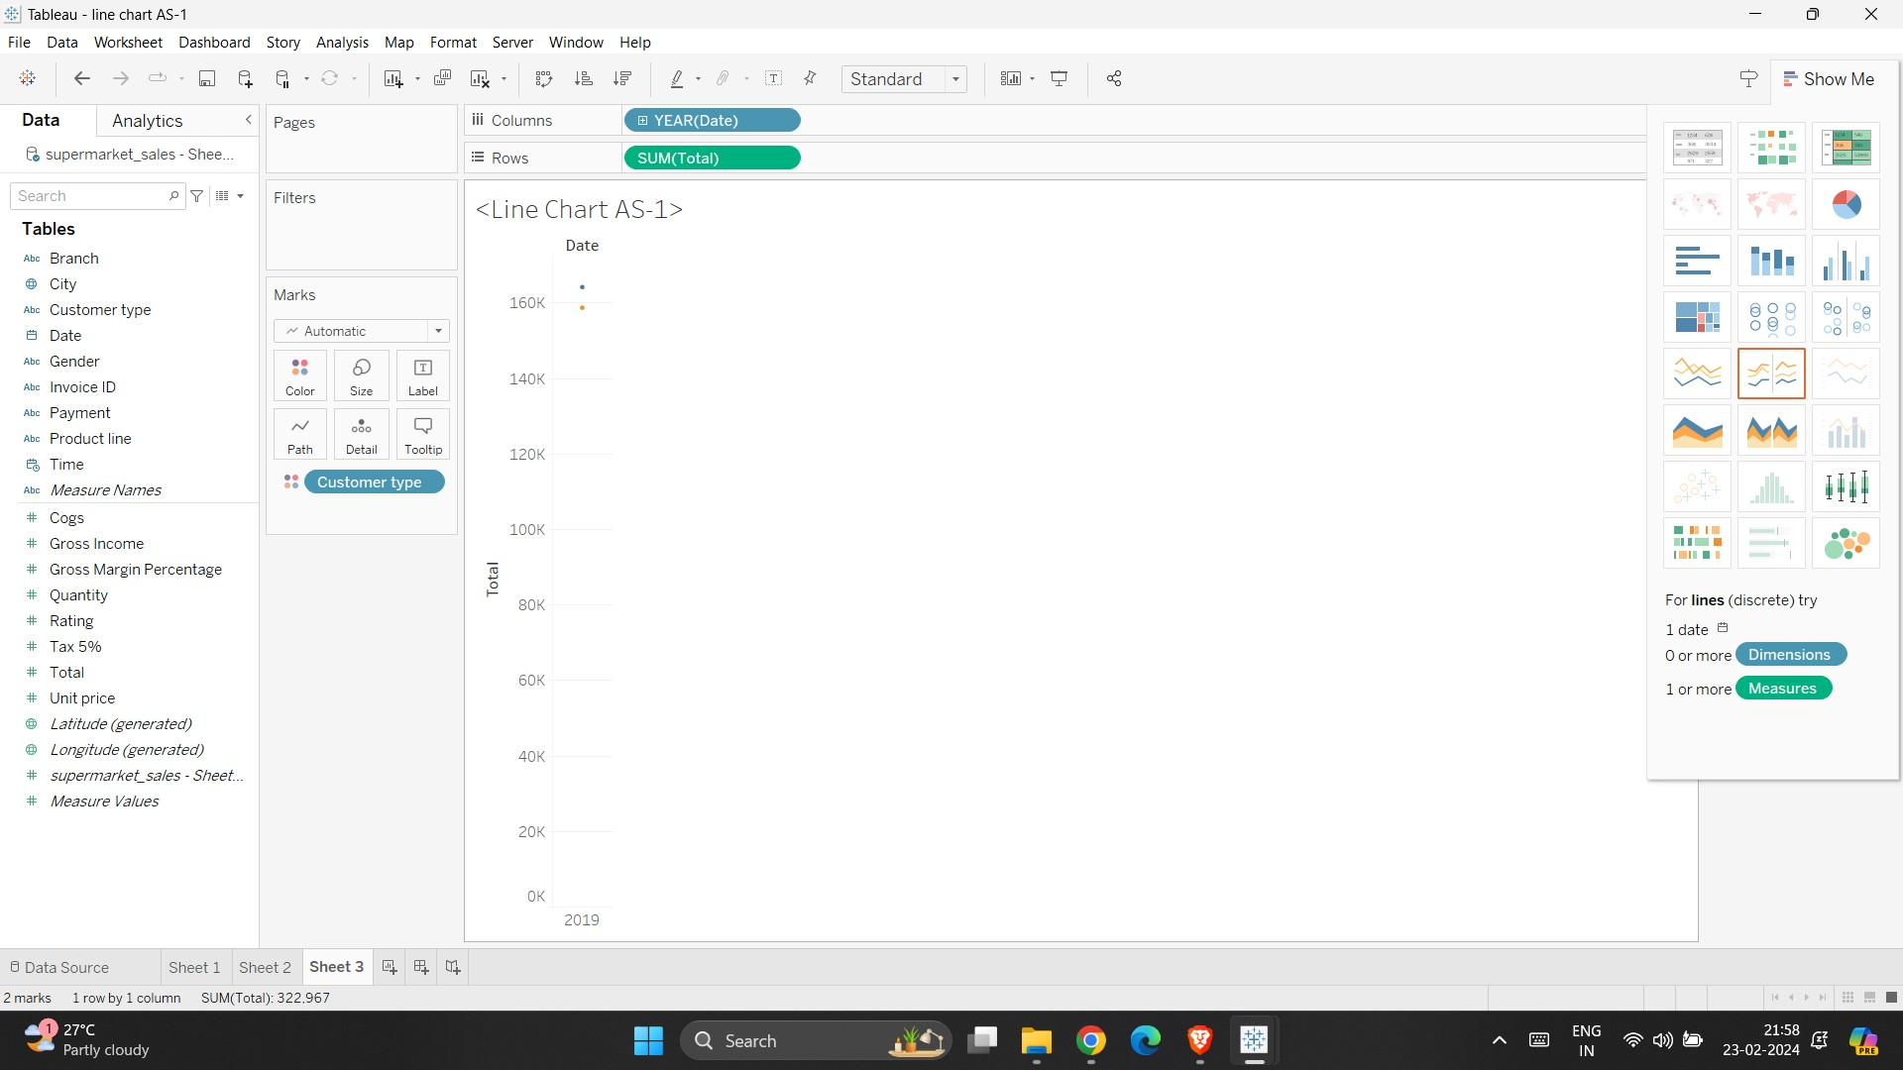

BUBBLE CHART:

